2016 RACE TO RENEW- Save My Seats

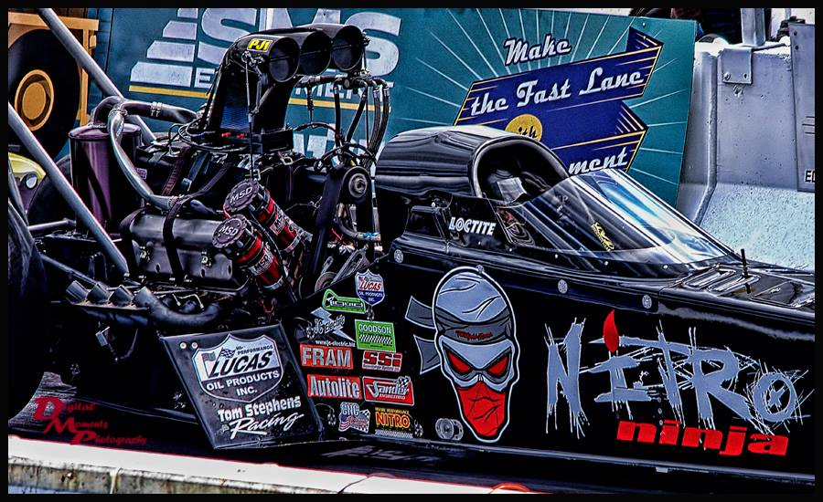



Hey Race Fans – Mark your calendars, our 2016 Race Season will be hotter than ever. The snow has fallen after an outstanding 2015 season and yet, we are looking ahead to our 19th year as Canada’s Premier Motorsport Complex. Back for the 14th Nitro Charged year:

**Mopar IHRA Rocky Mountain Nationals presented by Good Vibrations Motorsports**

**July 15-17, 2016.**

***Our engines are revving for another incredible racing season at Castrol Raceway! To get our best fans fired up and ready to race, we're making NOW a high-intensity month of winning.***

***RACE TO RENEW YOUR TICKET ORDER TODAY***

***You'll be automatically entered to win one of 50- $20 Castrol Coins and***

***One Exclusive Rocky Mountain Nationals VIP Weekend Experience!***

Winners will be selected every day between Nov. 10- Dec 10, 2015, so Race to Renew and place your order TODAY!

Fans who renew by the December 10th cut-off will be able to upgrade and/or relocate their seats and Motorhome Sites during the upgrade and relocation period: December 11-22, 2015.

***The Ultimate Upgrade: Thunder Alley “REINVENTED”***

**Back with More fun, more food, and more incredible VIP entertainment- We’re REINVENTING the Thunder Alley VIP Weekend Experience!** The All inclusive Event Experience: Members only hospitality lounge access, premium weekend seating, hot catered meals, unlimited beverages, exclusive gifts, private bar service, preferred parking, private autograph sessions, and much more.

QUICK & EASY: SAVE YOUR SEAT ONLINE: <http://castrolraceway.tix.com/renew.asp>.

*You will be prompted for your Order Number and Renewal Code which can be found on the included* ***Race To Renew*** *ordering information below*.

If you are mailing your order in, please print and fill out the bottom portion of this form before sending to the Castrol Raceway office with full payment. You can also contact the Castrol Raceway office directly at anytime (780) 461-5801, to renew your order over the phone or If you would like to upgrade your seats. You must contact the Castrol Raceway office to do so before the December 10, 2015. cutoff date. All upgrades will be processed on a first come-first serve basis.

Thank you for choosing Castrol Raceway as your Place to Play,

Owners & Management, **Castrol Raceway**

If you are mailing in your Save My Seat form to Castrol Raceway, please fill out the payment information below.  
  
**Jeff Hedrick**  
**Order Number: 13551804**  
  
Method of Payment:    VISA    MASTERCARD    CHECK    MONEY ORDER  
  
  
Credit Card #:____________________________   Expiration Date:__________  
  
  
Check #:______________    Amount Paid:______________  
  
If your mailing address has changed or is changing, please notify the Castrol Raceway office.